Experiment 18
Implement Perceptron based IRIS classification
Aim
To implement Perceptron-based Iris Flower Classification in Python.
Program
# Perceptron based Iris Classification

from sklearn.datasets import load_iris
from sklearn.linear_model import Perceptron
from sklearn.metrics import confusion_matrix, accuracy_score

# Load dataset
iris = load_iris()
X = iris.data
y = iris.target

# Create model
model = Perceptron()

# Train model
model.fit(X, y)

# Predict
y_pred = model.predict(X)

# Confusion Matrix
cm = confusion_matrix(y, y_pred)
print("Confusion Matrix:\n", cm)

# Accuracy
acc = accuracy_score(y, y_pred)
print("Accuracy:", acc)
Output
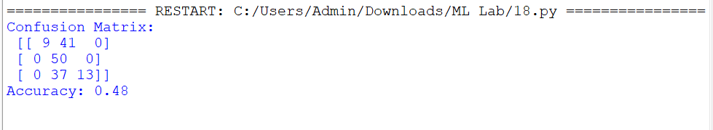

Result
The Perceptron-based Iris classification model was successfully implemented in Python, and its performance was evaluated using the confusion matrix and accuracy score.

